Make a Simple AirCraft Controller Game in Unity

This guide was written by a noob , for other noobs .

Setting the Stage
-----------------

Start with a new blank scene.

Add a directional light facing down.

Position the Camera to (0, 20, 0) . Rotate the camera to (90, 0, 0) .

Now to Make the object that will be the 'Ground'

Create a Cube : Position (0, -0.1, 0) . Scale (50, 0.2, 50) . Rename the cube Ground.

To give it colour, create a material, name it MatGround , change the colour settings, then drag 'MatGround' onto the cube 'Ground'. (my colour settings are R:17, G:131, B:45).

Now to Make the object that will be the 'Aircraft'

Create a Cube : Position (0, 2.5, 0) . Scale (2, 1, 2) . Rename the cube Aircraft.

To give it colour, create a material, name it MatAircraft , change the colour settings, then drag 'MatAircraft' onto the cube 'Aircraft'.

Now to Make the Script for the Aircraft.

Creat a script, name it ScriptAircraft. Drag 'ScriptAircraft' onto the cube 'Aircraft'.

Starting to Write the Sript

Have the Object follow the Mouse
--------------------------------

To do this we need to know 2 things : is the mouse being clicked, and where is the mouse pointing to on the stage?

Is the Mouse Being Clicked
--------------------------

Input.GetMouseButton(0) -> Input.GetMouseButtonDown(0) -> Input.GetMouseButtonUp(0)

http://unity3d.com/support/documentation/ScriptReference/Input.GetMouseButton.html

http://unity3d.com/support/documentation/ScriptReference/Input.GetMouseButtonDown.html

http://unity3d.com/support/documentation/ScriptReference/Input.GetMouseButtonUp.html

Where is the Mouse Pointing to on the Stage
-------------------------------------------

var rayHit : RaycastHit;
if(Physics.Raycast(Camera.main.ScreenPointToRay(Input.mousePosition), rayHit)) {
mousePoint = rayHit.point;

http://unity3d.com/support/documentation/ScriptReference/Physics.Raycast.html

http://unity3d.com/support/documentation/ScriptReference/Camera.ScreenPointToRay.html

Script
------

Delete everything in ScriptAircraft, then Copy and Paste in this Script :

#pragma strict

private var dragging : boolean = false;
private var startPosY : float = 0.0;
private var mousePoint : Vector3;

function Start () {
dragging = false;
startPosY = transform.position.y;
}

function Update () {

var rayHit : RaycastHit;
if(Physics.Raycast(Camera.main.ScreenPointToRay(Input.mousePosition), rayHit)) {
mousePoint = rayHit.point;

if (Input.GetMouseButtonDown(0)) {
if (!dragging) {transform.position = Vector3(mousePoint.x, startPosY, mousePoint.z); dragging = true;}
}
else if (Input.GetMouseButton(0)) {
if (dragging) {transform.position = Vector3(mousePoint.x, startPosY, mousePoint.z);}
}
else if (Input.GetMouseButtonUp(0)) {
if (dragging) {transform.position = Vector3(0, 0, 0); dragging = false;}
}
}

}

NOW when you play the scene, the Aircraft follows where the mouse is being clicked on the stage.

Drag Mouse to Create a Path to follow

Now to Make the object that will show the 'PathMarker' , the path the mouse is dragged.

Create a Sphere : Position (0, 0.1, 0) . Scale (0.2, 0.2, 0.2) .

To give it colour, create a material, name it MatPathMarker , change the colour settings, then drag 'MatPathMarker' onto the sphere. (my colour settings are R:255, G:255, B:0).

Create a Prefab , name it PrefabPathMarker . Drag the sphere into 'PrefabPathMarker' , then delete the sphere from the hierarchy.

The program should look something like this :

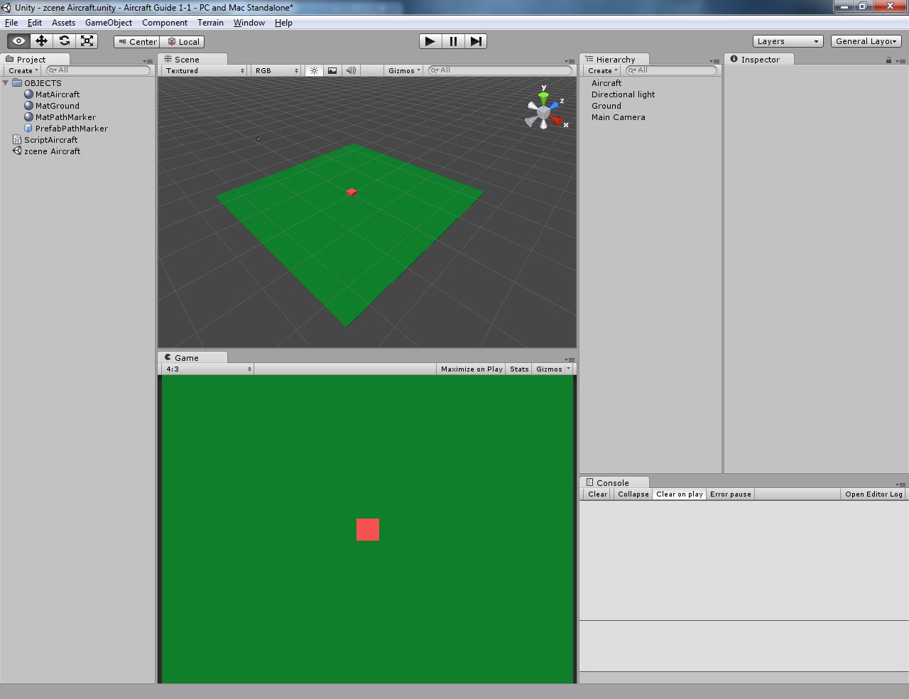

Script
------

Delete everything in ScriptAircraft, then Copy and Paste in this Script :

#pragma strict

private var dragging : boolean = false;
private var moving : boolean = false;
private var countDrag : int = 0;
private var countMove : int = 0;
private var mousePosition : Vector3;
private var mousePoint : Vector3;
private var pointCurrent : Vector3;
private var pointStore : Vector3;
private var posStoreX : Array = [];
private var posStoreZ : Array = [];
private var arrayPathMarker : GameObject[] = new GameObject[100];
var objectPathMarker : GameObject;

function Start () {
dragging = false;
}

function Update () {
// note - raycast needs a surface to hit against
var rayHit : RaycastHit;
if(Physics.Raycast(Camera.main.ScreenPointToRay(Input.mousePosition), rayHit)) {
// where did the raycast hit in the world - position of rayhit
if (dragging) {print ("rayHit.point : " + rayHit.point + " (mousePoint)");}
mousePoint = rayHit.point;

if (Input.GetMouseButtonDown(0)) {
OnTouchBegin(mousePoint);
}
else if (Input.GetMouseButton(0)) {
OnTouchMove(mousePoint);
}
else if (Input.GetMouseButtonUp(0)) {
OnTouchEnd(mousePoint);
}
}
}

function OnTouchBegin (pointCurrent : Vector3) {
countDrag = 0;
posStoreX.Clear();
posStoreZ.Clear();
AddSplinePoint(pointCurrent);
dragging = true;
moving = false;
}

function OnTouchMove (pointCurrent : Vector3) {
if ((dragging) && (countDrag < 100)) {
print("countDrag " + countDrag);
AddSplinePoint(pointCurrent);
} else {
dragging = false;
moving = true;
}
}

function OnTouchEnd (pointCurrent : Vector3) {
dragging = false;
moving = true;
}

function AddSplinePoint (pointStore : Vector3) {
// store co-ordinates
posStoreX[countDrag] = pointStore.x;
posStoreZ[countDrag] = pointStore.z;

// show path : Instantiate and load position into array as gameObject
arrayPathMarker[countDrag] = Instantiate(objectPathMarker, Vector3(pointStore.x, 0, pointStore.z), transform.rotation);
print (arrayPathMarker[countDrag].transform.position);

// next position
countDrag ++;
}

function FixedUpdate () {
// move gameObject
if (moving) {
// remove path marker
Destroy (arrayPathMarker[countMove]);

// move gameObject along path
transform.position = Vector3(posStoreX[countMove], 0, posStoreZ[countMove]);

// next position
countMove ++;
if (countMove >= posStoreX.length) {moving = false;} // stop at end of path
} else {
countMove = 0;
}

if (Input.GetKeyDown("r")) {print ("posStoreX "+posStoreX+" : posStoreZ "+posStoreZ);}
}

Before you play the scene, the Aircraft has a variable in the Inspector called 'Object Path Marker' , drag the 'PrefabPathMarker' into this place.

NOW when you play the scene, the Aircraft follows where the mouse has being clicked and dragged , After the drag. The path is shown with markers.

Follow at a Constant Speed

Now to make the object follow the path at a constant speed , not how fast the waypoints were created.

Script
------

Delete everything in ScriptAircraft, then Copy and Paste in this Script :

#pragma strict

private var dragging : boolean = false;
private var moving : boolean = false;
private var countDrag : int = 0;
private var countMove : int = 0;
private var mousePosition : Vector3;
private var mousePoint : Vector3;
private var pointCurrent : Vector3;
private var pointStore : Vector3;
private var posStoreX : Array = [];
private var posStoreZ : Array = [];
private var arrayPathMarker : GameObject[] = new GameObject[100];
var objectPathMarker : GameObject;

private var targetWaypoint : Vector3;
private var moveDirection : Vector3;
var moveSpeed : float = 3.0;

private var travelling : boolean = false;

function Start () {
dragging = false;
}

function Update () {
//
if (!moving) {
var rayHit : RaycastHit;
if(Physics.Raycast(Camera.main.ScreenPointToRay(Input.mousePosition), rayHit)) {
mousePoint = rayHit.point;

if (Input.GetMouseButtonDown(0)) {
OnTouchBegin(mousePoint);
}
else if (Input.GetMouseButton(0)) {
if (dragging) {OnTouchMove(mousePoint);} // check in-case mouse is down when object travelling is set to false
}
else if (Input.GetMouseButtonUp(0)) {
if (dragging) {OnTouchEnd(mousePoint);} // check in-case mouse is released when object travelling is set to false
}
}
}
}

function OnTouchBegin (pointCurrent : Vector3) {
countDrag = 0;
posStoreX.Clear();
posStoreZ.Clear();
AddSplinePoint(pointCurrent);
dragging = true;
moving = false;
}

function OnTouchMove (pointCurrent : Vector3) {
if ((dragging) && (countDrag < 100)) {
AddSplinePoint(pointCurrent);
travelling = true;
} else {
dragging = false;
moving = true;
}
}

function OnTouchEnd (pointCurrent : Vector3) {
dragging = false;
moving = true;
}

function AddSplinePoint (pointStore : Vector3) {
// store co-ordinates
posStoreX[countDrag] = pointStore.x;
posStoreZ[countDrag] = pointStore.z;

// show path : Instantiate and load position into array as gameObject
arrayPathMarker[countDrag] = Instantiate(objectPathMarker, Vector3(pointStore.x, 0, pointStore.z), transform.rotation);

// next position
countDrag ++;
}

function FixedUpdate () {
// move gameObject
if ((travelling) && (posStoreX[countMove] != null)){

// --

// move aircraft along path
targetWaypoint = Vector3(posStoreX[countMove], 0, posStoreZ[countMove]);
moveDirection = targetWaypoint - transform.position;

if(moveDirection.magnitude < 1) {
Destroy (arrayPathMarker[countMove]); // remove current path marker
countMove++; // next waypoint position
} else {
transform.position += moveDirection.normalized * moveSpeed * Time.deltaTime; // move gameObject
}

// --

if (countMove >= posStoreX.length) {finishTravelling ();} // stop at end of path
} else {
countMove = 0;
}

if (Input.GetKeyDown("r")) {print ("posStoreX "+posStoreX+" : posStoreZ "+posStoreZ);}
}

function finishTravelling () {
countMove = 0;
moving = false;
travelling = false;
}

Don't forget to drag the 'PrefabPathMarker' into 'Object Path Marker'.

Click on Object
---------------

Now to make the object Clickable , so that it doesn't make a path unless it is clicked on.

Script
------

Delete everything in ScriptAircraft, then Copy and Paste in this Script :

#pragma strict

private var dragging : boolean = false;
private var moving : boolean = false;
private var travelling : boolean = false;
private var countDrag : int = 0;
private var countMove : int = 0;
private var mousePosition : Vector3;
private var mousePoint : Vector3;
private var pointCurrent : Vector3;
private var pointStore : Vector3;
private var targetWaypoint : Vector3;
private var moveDirection : Vector3;
var moveSpeed : float = 3.0;
private var wayRotation : Quaternion;
var damping : float = 6.0;
private var posStoreX : Array = [];
private var posStoreZ : Array = [];
private var arrayPathMarker : GameObject[] = new GameObject[100];
var objectPathMarker : GameObject;

private var imSelected : Transform;
private var imClickedOn : boolean = false;
private var startPosY : float = 0.0;

function Start () {
dragging = false;
startPosY = transform.position.y;
}

function Update () {
//

//
if (!moving) {
var rayHit : RaycastHit;
if(Physics.Raycast(Camera.main.ScreenPointToRay(Input.mousePosition), rayHit)) {
mousePoint = rayHit.point;

// select this object from being clicked on
imSelected = rayHit.transform;
if (imSelected == this.transform) {imClickedOn = true;}

if (Input.GetMouseButtonDown(0)) {
print("imSelected NOW - " + imClickedOn);
if (imClickedOn) {OnTouchBegin(mousePoint);} // check if object has been clicked on
}
else if (Input.GetMouseButton(0)) {
if (dragging) {OnTouchMove(mousePoint);} // check in-case mouse is down when object travelling is set to false with (dragging)
}
else if (Input.GetMouseButtonUp(0)) {
if (dragging) {OnTouchEnd(mousePoint);} // check in-case mouse is released when object travelling is set to false with (dragging)
}
}
}
}

function OnTouchBegin (pointCurrent : Vector3) {
countDrag = 0;
posStoreX.Clear();
posStoreZ.Clear();
AddSplinePoint(pointCurrent);
dragging = true;
moving = false;
}

function OnTouchMove (pointCurrent : Vector3) {
if ((dragging) && (countDrag < 100)) {
AddSplinePoint(pointCurrent);
travelling = true;
} else {
dragging = false;
moving = true;
}
}

function OnTouchEnd (pointCurrent : Vector3) {
dragging = false;
moving = true;
if (imSelected) {imSelected = null; imClickedOn = false;} // reset 'select this object if clicked on'
}

function AddSplinePoint (pointStore : Vector3) {
// store co-ordinates
posStoreX[countDrag] = pointStore.x;
posStoreZ[countDrag] = pointStore.z;
// show path : Instantiate and load position into array as gameObject
arrayPathMarker[countDrag] = Instantiate(objectPathMarker, Vector3(pointStore.x, startPosY, pointStore.z), transform.rotation);
// next position
countDrag ++;
}

function FixedUpdate () {

// -- move gameObject
if ((travelling) && (posStoreX[countMove] != null)){

// --

// move aircraft along path in time
targetWaypoint = Vector3(posStoreX[countMove], startPosY, posStoreZ[countMove]);
moveDirection = targetWaypoint - transform.position;

if(moveDirection.magnitude < 1) {
Destroy (arrayPathMarker[countMove]); // remove current path marker
countMove++; // next waypoint position
} else {
transform.position += moveDirection.normalized * moveSpeed * Time.deltaTime; // move gameObject
//transform.LookAt(targetWaypoint);
wayRotation = Quaternion.LookRotation(targetWaypoint - transform.position);
transform.rotation = Quaternion.Slerp(transform.rotation, wayRotation , Time.deltaTime * damping);
}

if (countMove >= posStoreX.length) {finishTravelling ();} // stop at end of path

// --

} else {
countMove = 0;
}

// -- aircraft flying normally
if (!travelling) {
transform.position += (transform.forward * moveSpeed * Time.deltaTime);
}

// print out of current stored array
if (Input.GetKeyDown("r")) {print ("posStoreX "+posStoreX+" : posStoreZ "+posStoreZ);}
}

function finishTravelling () {
countMove = 0;
moving = false;
if (imSelected) {imSelected = null; imClickedOn = false;} // reset 'select this object if clicked on'
travelling = false;
}

Don't forget to drag the 'PrefabPathMarker' into 'Object Path Marker'.

Landing Zone

Now to make somewhere for the Aircraft to Land.

Now to Make the object that will show the 'LandingZone' , the place the mouse is dragged to.

Create a Sphere : Position (0, 0.125, 0) . Scale (2, 0.25, 2) . Rename this LandingZone.

To give it colour, create a material, name it MatLandingZone , change the colour settings, then drag 'MatLandingZone' onto the sphere. (my colour settings are R:0, G:0, B:255, Alpha:64). (set the material shader to Transparent -> Diffuse)

There are 2 landing zones for this example. Copy your object 'LandingZone' .
Move one LandingZone to Position (6, 0, 8) , and the other to Position (10, 0, 3) .

The program should look something like this :

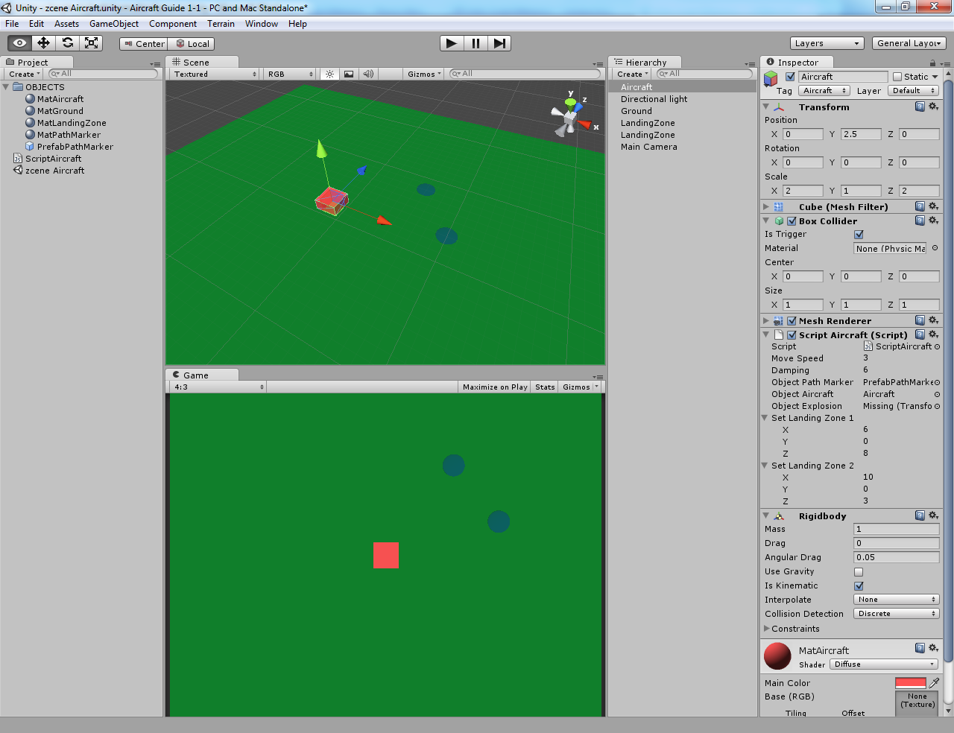
Script
------

Delete everything in ScriptAircraft, then Copy and Paste in this Script :

#pragma strict

private var dragging : boolean = false;
private var imMoving : boolean = false;
private var imClickedOn : boolean = false;
private var imTravelling : boolean = false;
private var imLanding : boolean = false;
private var startPosY : float = 0.0;
private var countDrag : int = 0;
private var countMove : int = 0;
private var mousePosition : Vector3;
private var mousePoint : Vector3;
private var pointCurrent : Vector3;
private var pointStore : Vector3;
private var targetWaypoint : Vector3;
private var moveDirection : Vector3;
var moveSpeed : float = 3.0;
private var wayRotation : Quaternion;
var damping : float = 6.0;
private var posStoreX : Array = [];
private var posStoreZ : Array = [];
private var arrayPathMarker : GameObject[] = new GameObject[100];
var objectPathMarker : GameObject;

private var imSelected : Transform;

var objectAircraft : GameObject;

var setLandingZone1 : Vector3 = Vector3(6, 0, 8);
var setLandingZone2 : Vector3 = Vector3(10, 0, 3);
private var posRunwayX : Array = [12.75, 15.75, 14.75];
private var posRunwayZ : Array = [8, 8, -0.5];

function Start () {
dragging = false;
startPosY = transform.position.y;
}

function Update () {
// check if not already following a trail
if (!imMoving) {
var rayHit : RaycastHit;
if(Physics.Raycast(Camera.main.ScreenPointToRay(Input.mousePosition), rayHit)) {
mousePoint = rayHit.point;

// select this object if it's being clicked on
imClickedOn = false; // reset as raycast is set every frame , if mouseover this, stays flagged as true without this
imSelected = rayHit.transform;
if (imSelected == this.transform) {imClickedOn = true;}

if (Input.GetMouseButtonDown(0)) {
if (imClickedOn) {OnTouchBegin(mousePoint);} // check if object has been clicked on
}
else if (Input.GetMouseButton(0)) {
if (dragging) {OnTouchMove(mousePoint);} // check in-case mouse is down when object travelling is set to false with (dragging)
}
else if (Input.GetMouseButtonUp(0)) {
if (dragging) {OnTouchEnd(mousePoint);} // check in-case mouse is released when object travelling is set to false with (dragging)
}
}
}
}

function OnTouchBegin (pointCurrent : Vector3) {
// destroy path markers and array
for (var i = 0; i< 100; i++) {
Destroy (arrayPathMarker[i]); // this destroys
arrayPathMarker[i]=null; // this sets to null (inst obj remains)
}
//
countDrag = 0;
posStoreX.Clear();
posStoreZ.Clear();
AddSplinePoint(pointCurrent);
dragging = true;
imMoving = false;
}

function OnTouchMove (pointCurrent : Vector3) {
if ((dragging) && (countDrag < 100)) {
AddSplinePoint(pointCurrent);
imTravelling = true;
} else {
dragging = false;
imMoving = true;
}
}

function OnTouchEnd (pointCurrent : Vector3) {
dragging = false;
imMoving = true;
if (imSelected) {imSelected = null; imClickedOn = false;} // resets state -> 'select this object if clicked on'
}

function AddSplinePoint (pointStore : Vector3) {
// store co-ordinates
posStoreX[countDrag] = pointStore.x;
posStoreZ[countDrag] = pointStore.z;
// show path : Instantiate and load position into array as gameObject
arrayPathMarker[countDrag] = Instantiate(objectPathMarker, Vector3(pointStore.x, 0.2, pointStore.z), transform.rotation);
// next position
countDrag ++;
}

function FixedUpdate () {

// -- move gameObject --

// check if following a trail and there is a trail marker to follow
if ((imTravelling) && (posStoreX[countMove] != null)){

// --

// move aircraft along path in time
targetWaypoint = Vector3(posStoreX[countMove], startPosY, posStoreZ[countMove]);
moveDirection = targetWaypoint - transform.position;

// check if the waypoint has been reached
if(moveDirection.magnitude < 1) {
Destroy (arrayPathMarker[countMove]); // remove current path marker
countMove++; // next waypoint position
// still move forward (stops stuttery efect when moving)
transform.position += moveDirection.normalized * moveSpeed * Time.deltaTime; // move gameObject over time
wayRotation = Quaternion.LookRotation(targetWaypoint - transform.position); // find rotation
transform.rotation = Quaternion.Slerp(transform.rotation, wayRotation , Time.deltaTime * damping); // rotate gameObject over time
} else {
transform.position += moveDirection.normalized * moveSpeed * Time.deltaTime; // move gameObject over time
wayRotation = Quaternion.LookRotation(targetWaypoint - transform.position); // find rotation
transform.rotation = Quaternion.Slerp(transform.rotation, wayRotation , Time.deltaTime * damping); // rotate gameObject over time
}

if (countMove >= posStoreX.length) {finishTravelling ();} // stop at end of path

// --

} else {
if (!imLanding) {countMove = 0;} // stops the var resetting stopping the landing procedure
}

// -- aircraft flying normally
if (!imTravelling) {
transform.position += (transform.forward * moveSpeed * Time.deltaTime);
}

// -- Landing aircraft

// Landing Procedure
if (imLanding) {
//reset all other vars
dragging = false;
imMoving = false;
imClickedOn = false;
imTravelling = false;
// destroy path markers and array
for (var p = 0; p< 100; p++) {
Destroy (arrayPathMarker[p]); // this destroys
arrayPathMarker[p]=null; // this sets to null (inst obj remains)
}

// follow runway waypoints
targetWaypoint = Vector3(posRunwayX[countMove], 1.125, posRunwayZ[countMove]);
moveDirection = targetWaypoint - transform.position;

// check if the waypoint has been reached
if(moveDirection.magnitude < 1) {
countMove++; // next waypoint position
} else {
transform.position += moveDirection.normalized * Time.deltaTime; // move gameObject over time => (moveSpeed/2) * Time.deltaTime;
wayRotation = Quaternion.LookRotation(targetWaypoint - transform.position); // find rotation
transform.rotation = Quaternion.Slerp(transform.rotation, wayRotation , Time.deltaTime * damping); // rotate gameObject over time
}

// move this aircraft and clone another aircraft
if (countMove >= posRunwayX.length) {
relocateAircraft ();
}
}

// -- boundaries
if (transform.position.x < -20) {transform.position.x += 40;}
if (transform.position.x > 20) {transform.position.x -= 40;}
if (transform.position.z < -15) {transform.position.z += 30;}
if (transform.position.z > 15) {transform.position.z -= 30;}

// print out of current stored array
if (Input.GetKeyDown("r")) {print ("posStoreX "+posStoreX+" : posStoreZ "+posStoreZ);}
}

function finishTravelling () {
countMove = 0;
imMoving = false;
if (imSelected) {imSelected = null; imClickedOn = false;} // reset 'select this object if clicked on'

// check for if a landing zone is in range
if (((setLandingZone1 - transform.position).magnitude) < 4.0) {imLanding = true; countMove = 0;}
if (((setLandingZone2 - transform.position).magnitude) < 4.0) {imLanding = true; countMove = 0;}
//

imTravelling = false;
}

function relocateAircraft () {
//reset all other vars
dragging = false;
imMoving = false;
imClickedOn = false;
imTravelling = false;
//
countMove = 0;
imLanding = false;
// move aircraft
transform.position = Vector3((Random.Range(-6,6)), startPosY, -14);
transform.rotation = Quaternion.Euler(0, (Random.Range(0,45)), 0);
// create new aircraft
Instantiate (objectAircraft, Vector3(-18, startPosY, (Random.Range(-10,10))), Quaternion.Euler(0, (Random.Range(60,120)), 0));
}

Note in the inspector there a are variables for changing the Landing Zone Positions, so you can set the position of where the landing zone is to where you placed it on the stage.

I have included a command where : when an Aircraft lands , it Instantiates a new Aircraft.

Before you play the scene, the Aircraft has a variable in the Inspector called 'Object Aircraft' , drag the 'Aircraft' into this place.

Don't forget to drag the 'PrefabPathMarker' into 'Object Path Marker'.

I added runways by simply drawing some boxes, scaling and positioning them.

Cube 1 : Position (10, 0.05, 8)
Scale (11, 0.1, 3)

Cube 2 : Position (11.3, 0.05, 5.22)
Rotation (0, -60, 0)
Scale (8, 0.1, 3)

Cube 3 : Position (15, 0.05, 4)
Rotation (0, 90, 0)
Scale (11, 0.1, 3)

Cube 4 : Position (14, 0.05, 0)
Scale (4, 0.1, 3)

Crashes

Now to add Collisions. Collisions don't count when the aircraft is landing.

For collision detection we shall be using -> OnTriggerEnter (other : Collider)

http://unity3d.com/support/documentation/ScriptReference/Collider.OnTriggerEnter.html

Note that this command only works when 'Note that trigger events are only sent if one of the colliders also has a rigidbody attached.'.

For this , some setting up needs to be done first.

Attach Rigidbody
----------------

Click on the object 'Aircraft'.

Add Component -> Physics -> Rigidbody

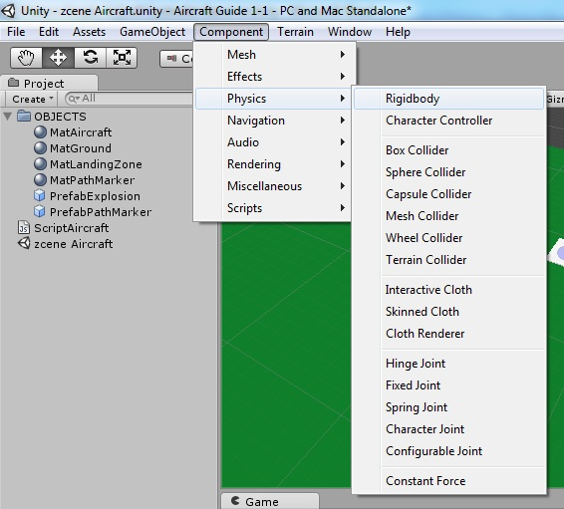

In the Aircraft Inspector under Rigidbody, Untick 'Use Gravity' , and Tick 'Is Kinematic' .

This is done as we need the rigidbody component for the command, but are not using the real physics of the rigidbody (i.e. the aircraft is moved with transform , not AddForce) .

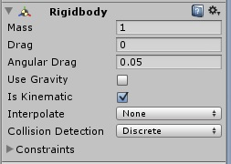

Add a Tag
---------

the command being used is :

function OnTriggerEnter (other : Collider) {
if ((other.tag == "Aircraft"

This is looking for a Tag to see if it has hit another object tagged with the Tag.

Click on the object 'Aircraft'

In the Aircraft Inspector, Tag probably has the setting 'Untagged' . Click on this, then click 'Add Tag ...'

Expand the menu Tags , an in an empty Element Type in Aircraft.

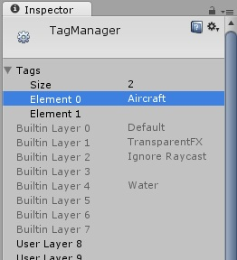

Now a tag has been created , it still needs to be applied to the object 'Aircraft'.

Click on the object 'Aircraft'

In the Aircraft Inspector, Tag probably has the setting 'Untagged' . Now 'Aircraft' should be in the menu , click and select it.

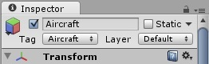

Also we are using a 'Trigger' , so the Aircraft 's collider needs to be set to 'Is Trigger' true.

Click on the object 'Aircraft'

In the Aircraft Inspector, under Box Collider , Tick the box 'Is Trigger'.

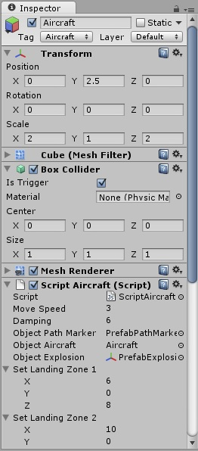

Then we also have to add an explosion . For my project , I just used the Small Explosion in the Standard Assets .

Drag the Explosion to the Hierarchy (or make your own with a particle system).

Make a Prefab , name it PrefabExplosion.

Drag the explosion into “PrefabExplosion” , then delete the explosion from the Hierarchy.

Script
------

Delete everything in ScriptAircraft, then Copy and Paste in this Script :

#pragma strict

private var dragging : boolean = false;
private var imMoving : boolean = false;
private var imClickedOn : boolean = false;
private var imTravelling : boolean = false;
private var imLanding : boolean = false;
private var startPosY : float = 0.0;
private var countDrag : int = 0;
private var countMove : int = 0;
private var mousePosition : Vector3;
private var mousePoint : Vector3;
private var pointCurrent : Vector3;
private var pointStore : Vector3;
private var targetWaypoint : Vector3;
private var moveDirection : Vector3;
var moveSpeed : float = 3.0;
private var wayRotation : Quaternion;
var damping : float = 6.0;
private var posStoreX : Array = [];
private var posStoreZ : Array = [];
private var arrayPathMarker : GameObject[] = new GameObject[100];
var objectPathMarker : GameObject;

private var imSelected : Transform;

var objectAircraft : GameObject;
var objectExplosion : Transform;

var setLandingZone1 : Vector3 = Vector3(6, 0, 8);
var setLandingZone2 : Vector3 = Vector3(10, 0, 3);
private var posRunwayX : Array = [12.75, 15.75, 14.75];
private var posRunwayZ : Array = [8, 8, -0.5];

function Start () {
dragging = false;
startPosY = transform.position.y;
}

function Update () {
// check if not already following a trail
if (!imMoving) {
var rayHit : RaycastHit;
if(Physics.Raycast(Camera.main.ScreenPointToRay(Input.mousePosition), rayHit)) {
mousePoint = rayHit.point;

// select this object if it's being clicked on
imClickedOn = false; // reset as raycast is set every frame , if mouseover this, stays flagged as true without this
imSelected = rayHit.transform;
if (imSelected == this.transform) {imClickedOn = true;}

if (Input.GetMouseButtonDown(0)) {
if (imClickedOn) {OnTouchBegin(mousePoint);} // check if object has been clicked on
}
else if (Input.GetMouseButton(0)) {
if (dragging) {OnTouchMove(mousePoint);} // check in-case mouse is down when object travelling is set to false with (dragging)
}
else if (Input.GetMouseButtonUp(0)) {
if (dragging) {OnTouchEnd(mousePoint);} // check in-case mouse is released when object travelling is set to false with (dragging)
}
}
}
}

function OnTouchBegin (pointCurrent : Vector3) {
// destroy path markers and array
for (var i = 0; i< 100; i++) {
Destroy (arrayPathMarker[i]); // this destroys
arrayPathMarker[i]=null; // this sets to null (inst obj remains)
}
//
countDrag = 0;
posStoreX.Clear();
posStoreZ.Clear();
AddSplinePoint(pointCurrent);
dragging = true;
imMoving = false;
}

function OnTouchMove (pointCurrent : Vector3) {
if ((dragging) && (countDrag < 100)) {
AddSplinePoint(pointCurrent);
imTravelling = true;
} else {
dragging = false;
imMoving = true;
}
}

function OnTouchEnd (pointCurrent : Vector3) {
dragging = false;
imMoving = true;
if (imSelected) {imSelected = null; imClickedOn = false;} // resets state -> 'select this object if clicked on'
}

function AddSplinePoint (pointStore : Vector3) {
// store co-ordinates
posStoreX[countDrag] = pointStore.x;
posStoreZ[countDrag] = pointStore.z;
// show path : Instantiate and load position into array as gameObject
arrayPathMarker[countDrag] = Instantiate(objectPathMarker, Vector3(pointStore.x, 0.2, pointStore.z), transform.rotation);
// next position
countDrag ++;
}

function FixedUpdate () {

// -- move gameObject --

// check if following a trail and there is a trail marker to follow
if ((imTravelling) && (posStoreX[countMove] != null)){

// --

// move aircraft along path in time
targetWaypoint = Vector3(posStoreX[countMove], startPosY, posStoreZ[countMove]);
moveDirection = targetWaypoint - transform.position;

// check if the waypoint has been reached
if(moveDirection.magnitude < 1) {
Destroy (arrayPathMarker[countMove]); // remove current path marker
countMove++; // next waypoint position
// still move forward (stops stuttery efect when moving)
transform.position += moveDirection.normalized * moveSpeed * Time.deltaTime; // move gameObject over time
wayRotation = Quaternion.LookRotation(targetWaypoint - transform.position); // find rotation
transform.rotation = Quaternion.Slerp(transform.rotation, wayRotation , Time.deltaTime * damping); // rotate gameObject over time
} else {
transform.position += moveDirection.normalized * moveSpeed * Time.deltaTime; // move gameObject over time
wayRotation = Quaternion.LookRotation(targetWaypoint - transform.position); // find rotation
transform.rotation = Quaternion.Slerp(transform.rotation, wayRotation , Time.deltaTime * damping); // rotate gameObject over time
}

if (countMove >= posStoreX.length) {finishTravelling ();} // stop at end of path

// --

} else {
if (!imLanding) {countMove = 0;} // stops the var resetting stopping the landing procedure
}

// -- aircraft flying normally
if (!imTravelling) {
transform.position += (transform.forward * moveSpeed * Time.deltaTime);
}

// -- Landing aircraft

// Landing Procedure
if (imLanding) {
//reset all other vars
dragging = false;
imMoving = false;
imClickedOn = false;
imTravelling = false;
// destroy path markers and array
for (var p = 0; p< 100; p++) {
Destroy (arrayPathMarker[p]); // this destroys
arrayPathMarker[p]=null; // this sets to null (inst obj remains)
}

// follow runway waypoints
targetWaypoint = Vector3(posRunwayX[countMove], 1.125, posRunwayZ[countMove]);
moveDirection = targetWaypoint - transform.position;

// check if the waypoint has been reached
if(moveDirection.magnitude < 1) {
countMove++; // next waypoint position
} else {
transform.position += moveDirection.normalized * Time.deltaTime; // move gameObject over time => (moveSpeed/2) * Time.deltaTime;
wayRotation = Quaternion.LookRotation(targetWaypoint - transform.position); // find rotation
transform.rotation = Quaternion.Slerp(transform.rotation, wayRotation , Time.deltaTime * damping); // rotate gameObject over time
}

// move this aircraft and clone another aircraft
if (countMove >= posRunwayX.length) {
relocateAircraft ();
}
}

// -- boundaries
if (transform.position.x < -20) {transform.position.x += 40;}
if (transform.position.x > 20) {transform.position.x -= 40;}
if (transform.position.z < -15) {transform.position.z += 30;}
if (transform.position.z > 15) {transform.position.z -= 30;}

// print out of current stored array
if (Input.GetKeyDown("r")) {print ("posStoreX "+posStoreX+" : posStoreZ "+posStoreZ);}
}

function finishTravelling () {
countMove = 0;
imMoving = false;
if (imSelected) {imSelected = null; imClickedOn = false;} // reset 'select this object if clicked on'

// check for if a landing zone is in range
if (((setLandingZone1 - transform.position).magnitude) < 4.0) {imLanding = true; countMove = 0;}
if (((setLandingZone2 - transform.position).magnitude) < 4.0) {imLanding = true; countMove = 0;}
//

imTravelling = false;
}

function relocateAircraft () {
//reset all other vars
dragging = false;
imMoving = false;
imClickedOn = false;
imTravelling = false;
//
countMove = 0;
imLanding = false;
// move aircraft
transform.position = Vector3((Random.Range(-6,6)), startPosY, -14);
transform.rotation = Quaternion.Euler(0, (Random.Range(0,45)), 0);
Instantiate (objectAircraft, Vector3(-18, startPosY, (Random.Range(-10,10))), Quaternion.Euler(0, (Random.Range(60,120)), 0));
}

function OnTriggerEnter (other : Collider) {
if ((other.tag == "Aircraft") && (!imLanding)) {
// empty path marker array
for (var i = 0; i< 100; i++) {
Destroy (arrayPathMarker[i]); // this destroys
arrayPathMarker[i]=null; // this sets to null (inst obj remains)
}
//destroy Aircraft
Destroy(gameObject);
Instantiate (objectExplosion, transform.position, transform.rotation);
}
}

Before you play the scene, the Aircraft has a variable in the Inspector called 'Object Explosion' , drag the 'PrefabExplosion' into this place.

Don't forget to drag the 'PrefabPathMarker' into 'Object Path Marker' , and drag the 'Aircraft' into 'Object Aircraft' , and set the Landing Zone positions

Add a GUI

This is as far as I have reached in this project. The scene should look something like this :

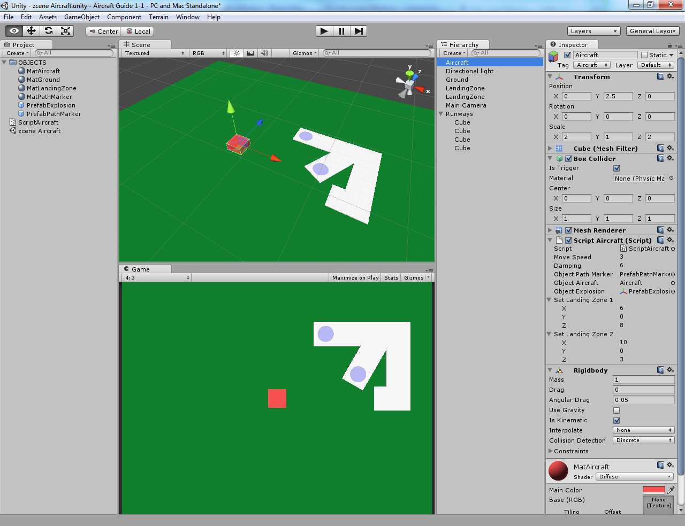

There are a few problems that need to be fixed :

- Waypoints set at strange places when dragging over another aircraft.
- Setting a No-Fly zone over the Airport
- Avoiding collisions whent eh aircraft are off the stage
- My counter for Aircraft in Flight is not working properly

Anyway , here is my script including a GUI and Timer ( NOTE – the Scene Manager Script is attached to the camera) :

ScriptAircraft :

#pragma strict

private var dragging : boolean = false;
private var imMoving : boolean = false;
private var imClickedOn : boolean = false;
private var imTravelling : boolean = false;
private var imLanding : boolean = false;
private var startPosY : float = 0.0;
private var countDrag : int = 0;
private var countMove : int = 0;
private var mousePosition : Vector3;
private var mousePoint : Vector3;
private var pointCurrent : Vector3;
private var pointStore : Vector3;
private var targetWaypoint : Vector3;
private var moveDirection : Vector3;
var moveSpeed : float = 3.0;
private var wayRotation : Quaternion;
var damping : float = 6.0;
private var posStoreX : Array = [];
private var posStoreZ : Array = [];
private var arrayPathMarker : GameObject[] = new GameObject[100];
var objectPathMarker : GameObject;

private var imSelected : Transform;

var objectAircraft : GameObject;
var objectExplosion : Transform;

var setLandingZone1 : Vector3 = Vector3(6, 0, 8);
var setLandingZone2 : Vector3 = Vector3(10, 0, 3);
private var posRunwayX : Array = [12.75, 15.75, 14.75];
private var posRunwayZ : Array = [8, 8, -0.5];

public var Scene_Manager : ScriptSceneManager;

function Start () {
dragging = false;
startPosY = transform.position.y;
}

function Update () {
// check if not already following a trail
if (!imMoving) {
var rayHit : RaycastHit;
if(Physics.Raycast(Camera.main.ScreenPointToRay(Input.mousePosition), rayHit)) {
mousePoint = rayHit.point;

// select this object if it's being clicked on
imClickedOn = false; // reset as raycast is set every frame , if mouseover this, stays flagged as true without this
imSelected = rayHit.transform;
if (imSelected == this.transform) {imClickedOn = true;}

if (Input.GetMouseButtonDown(0)) {
if (imClickedOn) {OnTouchBegin(mousePoint);} // check if object has been clicked on
}
else if (Input.GetMouseButton(0)) {
if (dragging) {OnTouchMove(mousePoint);} // check in-case mouse is down when object travelling is set to false with (dragging)
}
else if (Input.GetMouseButtonUp(0)) {
if (dragging) {OnTouchEnd(mousePoint);} // check in-case mouse is released when object travelling is set to false with (dragging)
}
}
}
}

function OnTouchBegin (pointCurrent : Vector3) {
// destroy path markers and array
for (var i = 0; i< 100; i++) {
Destroy (arrayPathMarker[i]); // this destroys
arrayPathMarker[i]=null; // this sets to null (inst obj remains)
}
//
countDrag = 0;
posStoreX.Clear();
posStoreZ.Clear();
AddSplinePoint(pointCurrent);
dragging = true;
imMoving = false;
}

function OnTouchMove (pointCurrent : Vector3) {
if ((dragging) && (countDrag < 100)) {
AddSplinePoint(pointCurrent);
imTravelling = true;
} else {
dragging = false;
imMoving = true;
}
}

function OnTouchEnd (pointCurrent : Vector3) {
dragging = false;
imMoving = true;
if (imSelected) {imSelected = null; imClickedOn = false;} // resets state -> 'select this object if clicked on'
}

function AddSplinePoint (pointStore : Vector3) {
// store co-ordinates
posStoreX[countDrag] = pointStore.x;
posStoreZ[countDrag] = pointStore.z;
// show path : Instantiate and load position into array as gameObject
arrayPathMarker[countDrag] = Instantiate(objectPathMarker, Vector3(pointStore.x, 0.2, pointStore.z), transform.rotation);
// next position
countDrag ++;
}

function FixedUpdate () {

// -- move gameObject --

// check if following a trail and there is a trail marker to follow
if ((imTravelling) && (posStoreX[countMove] != null)){

// --

// move aircraft along path in time
targetWaypoint = Vector3(posStoreX[countMove], startPosY, posStoreZ[countMove]);
moveDirection = targetWaypoint - transform.position;

// check if the waypoint has been reached
if(moveDirection.magnitude < 1) {
Destroy (arrayPathMarker[countMove]); // remove current path marker
countMove++; // next waypoint position
// still move forward (stops stuttery efect when moving)
transform.position += moveDirection.normalized * moveSpeed * Time.deltaTime; // move gameObject over time
wayRotation = Quaternion.LookRotation(targetWaypoint - transform.position); // find rotation
transform.rotation = Quaternion.Slerp(transform.rotation, wayRotation , Time.deltaTime * damping); // rotate gameObject over time
} else {
transform.position += moveDirection.normalized * moveSpeed * Time.deltaTime; // move gameObject over time
wayRotation = Quaternion.LookRotation(targetWaypoint - transform.position); // find rotation
transform.rotation = Quaternion.Slerp(transform.rotation, wayRotation , Time.deltaTime * damping); // rotate gameObject over time
}

if (countMove >= posStoreX.length) {finishTravelling ();} // stop at end of path

// --

} else {
if (!imLanding) {countMove = 0;} // stops the var resetting stopping the landing procedure
}

// -- aircraft flying normally
if (!imTravelling) {
transform.position += (transform.forward * moveSpeed * Time.deltaTime);
}

// -- Landing aircraft

// Landing Procedure
if (imLanding) {
//reset all other vars
dragging = false;
imMoving = false;
imClickedOn = false;
imTravelling = false;
// destroy path markers and array
for (var p = 0; p< 100; p++) {
Destroy (arrayPathMarker[p]); // this destroys
arrayPathMarker[p]=null; // this sets to null (inst obj remains)
}

// follow runway waypoints
targetWaypoint = Vector3(posRunwayX[countMove], 1.125, posRunwayZ[countMove]);
moveDirection = targetWaypoint - transform.position;

// check if the waypoint has been reached
if(moveDirection.magnitude < 1) {
countMove++; // next waypoint position
} else {
transform.position += moveDirection.normalized * Time.deltaTime; // move gameObject over time => (moveSpeed/2) * Time.deltaTime;
wayRotation = Quaternion.LookRotation(targetWaypoint - transform.position); // find rotation
transform.rotation = Quaternion.Slerp(transform.rotation, wayRotation , Time.deltaTime * damping); // rotate gameObject over time
}

// move this aircraft and clone another aircraft
if (countMove >= posRunwayX.length) {
relocateAircraft ();
}
}

// -- boundaries
if (transform.position.x < -20) {transform.position.x += 40;}
if (transform.position.x > 20) {transform.position.x -= 40;}
if (transform.position.z < -15) {transform.position.z += 30;}
if (transform.position.z > 15) {transform.position.z -= 30;}

// print out of current stored array
if (Input.GetKeyDown("r")) {print ("posStoreX "+posStoreX+" : posStoreZ "+posStoreZ);}
}

function finishTravelling () {
countMove = 0;
imMoving = false;
if (imSelected) {imSelected = null; imClickedOn = false;} // reset 'select this object if clicked on'

// check for if a landing zone is in range
if (((setLandingZone1 - transform.position).magnitude) < 4.0) {imLanding = true; countMove = 0;}
if (((setLandingZone2 - transform.position).magnitude) < 4.0) {imLanding = true; countMove = 0;}
//

imTravelling = false;
}

function relocateAircraft () {
//reset all other vars
dragging = false;
imMoving = false;
imClickedOn = false;
imTravelling = false;
//
countMove = 0;
imLanding = false;
// add landed to count
Scene_Manager.aircraftLanded += 1;
// move aircraft
transform.position = Vector3((Random.Range(-6,6)), startPosY, -14);
transform.rotation = Quaternion.Euler(0, (Random.Range(0,45)), 0);
// create new aircraft
Scene_Manager.aircraftInPlay += 1;
Instantiate (objectAircraft, Vector3(-18, startPosY, (Random.Range(-10,10))), Quaternion.Euler(0, (Random.Range(60,120)), 0));
}

function OnTriggerEnter (other : Collider) {
if ((other.tag == "Aircraft") && (!imLanding)) {
// empty path marker array
for (var i = 0; i< 100; i++) {
Destroy (arrayPathMarker[i]); // this destroys
arrayPathMarker[i]=null; // this sets to null (inst obj remains)
}
// add to count - lost, and remove from in-play
Scene_Manager.aircraftLost += 1;
Scene_Manager.aircraftInPlay -= 1;
//destroy Aircraft
Destroy(gameObject);
Instantiate (objectExplosion, transform.position, transform.rotation);
}
}

ScriptSceneManager :

#pragma strict

public var aircraftInPlay : int = 1;
public var aircraftLanded : int = 0;
public var aircraftLost : int = 0;
public var gameTimer : float = 150.0;

function Start () {

}

function FixedUpdate () {
gameTimer -= Time.deltaTime;
if (gameTimer <= 0) {print ("GAME OVER");}
}

function OnGUI () {
GUI.Box(Rect(10, 10, 100, 30), "Flying : "+ aircraftInPlay);
GUI.Box(Rect(10, 45, 100, 30), "Landed : "+ aircraftLanded);
GUI.Box(Rect(10, 80, 100, 30), "Lost X : "+ aircraftLost);

GUI.Box(Rect((Screen.width/2)-75, 10, 165, 30), "Time Left : "+ gameTimer);
}

If you liked this guide , or have any suggestions , please email me at :

webmaster@alucardj.net16.net

It would be nice to know this guide has helped someone out there ....

=]

